Weather Observations with the Omni Directional Weapon Location (OWL) Radar
Lesya Borowska¹, Dusan S. Zrnic², Yan Zhang³, and Guifu Zhang⁴
Justin Jackson⁵ and Colby Davis⁵

¹⁾Advanced Radar Research Center, University of Oklahoma (OU); ²⁾National Severe Storms Laboratory, Norman OK; ³⁾Electrical Engineering Dept., OU; ⁴⁾ Meteorology Department, OU; ⁵⁾Syracuse Research Corporation, Syracuse, NY.

PREFACE

The National Severe Storms Laboratory and the Advanced Radar Research Center are exploring the latest technologies in weather radars for possible transitions to operations by the National Weather Service. The polarimetric Phased Array Radar (PAR) has been identified as a leading candidate for replacement of the existing radars, the WSR-88Ds. Much research and studies are needed to develop the PAR so that its capabilities exceed the ones of the WSR-88D. Achieving excellent quality of the polarimetric measurements on the PAR is the most challenging demand of the system. It has yet to be proven. A planar and a cylindrical phased array antenna have been suggested for the PAR. In theory the polarization measurements are easier to calibrate on the radar with a cylindrical antenna. But, that antenna has other technical issues needing resolution. One is control/suppression of creeping waves and the other is the marginal experience by industry in building cylindrical PARs. To our knowledge the Syracuse Research Corporation (SRC) is the only company which has built and sells cylindrical PARs. The radar named Omni Directional Weapon Location (OWL) has no dual polarization. Nonetheless its cylindrical geometry presents an opportunity to test other issues in weather measurements. This report describes weather measurements with the OWL radar. The measurements are first of its kind, and readers should expect that many improvements and advancements of this technology, including dual polarization, will be forthcoming.

ABSTRACT

Based on the first observations of weather with the Omni directional Weapon Location (OWL) radar, the authors evaluate capability of the new cylindrical OWL radar to be used for weather applications. The OWL radar is a novel, multi-function radar technology demonstrator developed by RDECOM CERDEC Intelligence and Information Warfare Directorate (I2WD) and primed by SRC Inc. The emphasis of this paper is on beam steering in azimuth by commutating the beam positions. This is the first use of beam commutation on a cylidrical PAR (Phased-Array Radar) for weather observations. The stability of the receivers was tested in pure noise region. It is shown that the adjacent radials have only 0.4 dB variation in the noise power. The fields of reflectivity, Doppler velocity, and spectrum width were analyzed and compared with the nearby WSR-88D. After examination of all results, we concluded that the OWL radar can be used for quantitative weather observation.

1. Introduction
This is a summary report about some weather observations with the Omni directional Weapon Location (OWL) radar, Syracuse, NY (Lat: 43.1286$^{∘}$, Lon: -76.0842$^{∘}$), (Fig. 1). The OWL radar was developed by Intelligence and Information Warfare Directorate (I2WD) and primed by SRC Inc. (formerly Syracuse Research Corporation).
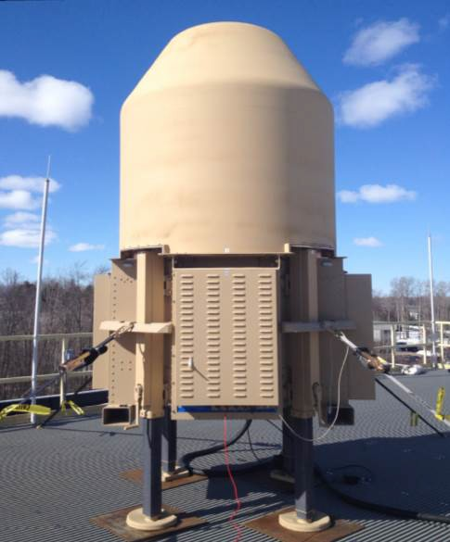
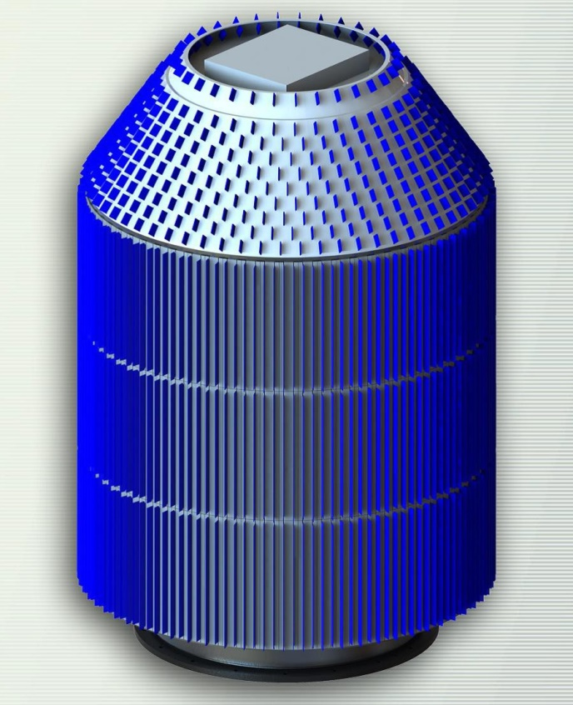
- (b)
Figure 1: The Omni directional Weapon Location (OWL) radar: (a) actual radar on top of a building in Syracuse and (b) depiction of the radiating elements.

It provides beyond hemispherical coverage between -20 deg and 90 deg elevation (Fig. 2). It is a phased-array radar that consists of three sections: a cylindrical section, a conical section above the cylinder, and a flat section intersecting the cone. The details of beam formation by the sections are proprietary. Nonetheless, the following is advertised by SRC Inc. The radar is configurable to cover 360$^{∘}$ azimuth or focused sector of desired size. It can track simultaneously many targets and performs multiple missions in parallel. It has decent resolution and fully coherent Doppler processing.

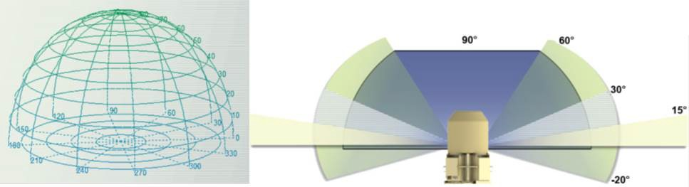
Figure 2: Schematics of volume coverage and cross section of the OWL radar.

Beam steering in elevation is by phase shifting and in azimuth it can be by phase shifting or by commutating the beam positions. In the data provided to us commutating was used. It is the first observations of weather with a comutating beam. Therefore, it is very relevant to our investigation of the CPAR technology.

2. Data
SRC Inc. provided several data sets from different precipitation events. The data files are in Matlab format. They consist of Doppler Spectra at evenly-spaced range locations and at two elevations, 2$^{∘}$ and 4.5$^{∘}$, and azimuths that cover 360$^{∘}$. Powers expressed as ratios in dB are also provided. To check the OWL radar’s observation of weather, we calculated and plotted the spectral moments (reflectivities, velocities, and spectrum widths) from these data and compared them with the spectral moments from the data sets obtained with a nearest WSR-88D (NEXRAD). The closest to the OWL radar is the KBGM, Binghamton, NY (Lat: 42.1994$^{∘}$, Lon: -75.9847$^{∘}$) radar. The distance between KBGM and the OWL radar is 102 km. The fields of reflectivities (Fig. 3a), Doppler velocity (Fig.3b), and spectrum width (Fig.3c) were obtained with KBGM on 12th of January, 2017 at 19:11 UTC. The elevation angle is 0.53$^{∘}$. The positions of KBGM and the OWL radar are depicted with the stars. The range white rings are 10 km apart and the azimuth white rings are at every 10$^{∘}$. The furthest north gate of KBGM that is shown in Fig. 3 is at 158.6 km. The furthest east gate is at 55.4 km and the furthest west gate at 59.9 km. The two arch black segments (Fig. 3a) show the area covered also with the OWL radar. The black quadrilateral (Fig. 3a) denotes the area from which data were processed to find the OWL’s radar constant.
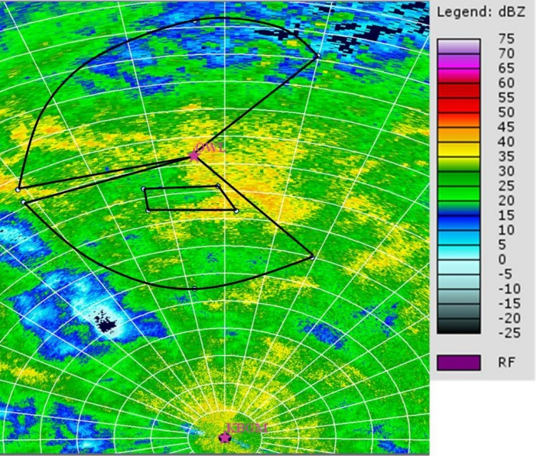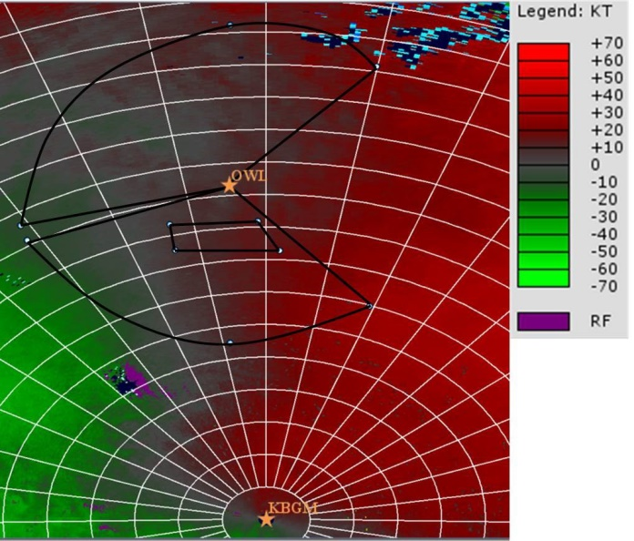
(a) (b)

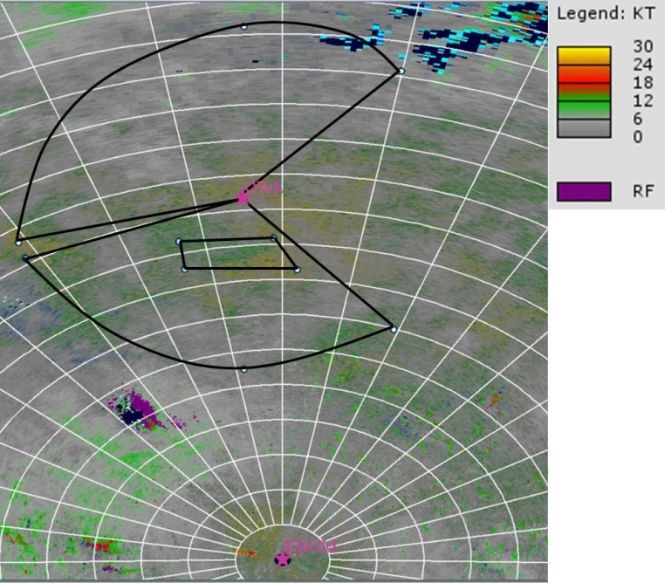
(c)
Figure 3. The fields of spectral moments that were obtained from the data set collected with the KBGM (Binghamton, NY, Lat: 42.1994$^{∘}$, Lon: -75.9847$^{∘}$) on 12th of January, 2017 at 19:11 UTC. The elevation angle is 0.53$^{∘}$. The positions of KBGM and the OWL radar (Syracuse, NY, Lat: 43.1286$^{∘}$, Lon: -76.0842$^{∘}$) are depicted with the stars. The range white rings are plotted every 10 km and the azimuth white rings are plotted every 10$^{∘}$. The fields were created by using NOAA Weather and Climate Toolkit. (a) Reflectivity field. (b) Doppler velocity field. (c) Spectrum width field.

The fields of the spectral moments, powers (Fig. 4a), not callibrated reflectivities (Fig. 4b), Doppler velocities (Fig. 4c), and spectrum width (Fig. 4d) from the data sampled with the OWL radar are depicted in Fig. 4. The data were collected with the OWL radar on 12th of January, 2017 at 19:07 UTC. The unambiguous velocity interval is from -66.98 m s⁻¹ to 64.88 m s⁻¹. In the region between 42$^{∘}$ and 140$^{∘}$ azimuth angles, the radar did not radiated. This area is later used to establish the noise level and stability of the receiving elements. The black quadrilateral (Fig. 4b) has the same meaning and position as in Fig. 3a.
(a) (b)
(c) (d)

Figure 4. The fields of spectral moments that were obtained from the data set collected with the OWL radar on 12th of January, 2017 at 19:07 UTC. The elevation angle is 4.5$^{∘}$. (a) Power field. (b) not calibrated reflectivity field. (c) Doppler velocity field. (d) Spectrum width field.$^{∘}$

Examination of the power (Fig. 4a) field reveals sporadic azimuthal discontinuities along some radials. This suggests that there could be stability issues in the transmission or reception parts of the radar system. These data were collected in a commutative scans and it is possible that in this process some change in gains occurs.
Recommendation: We suggest that a couple of azimuthal sectors of weather be scanned by comutating the beam and then repeat the scan by changing the phase of the columns to determine if a similar issue occurs. This might isolate the origin of the radial instability.
The non calibrated reflectivity in Fig. 4b was obtained by simply adding the range squared dependence of powers to the ones plotted in Fig. 4a.

2.1 OWL Radar Constant
For further analysis of the OWL radar data and calibration of reflectivity, the OWL radar constant needs to be established. For this purpose, an area where the radar’s beams overlap for more than 10 % was found. Because of the distance between two radars, their difference in elevation angles, and absence of OWL radar data in some locations, the overlaping region is relativley small. It is indicated with the black quadrilateral in Figs. 3a and 4b. The histograms of reflectivities measured with both radars (blue - for KBGM, magenta - for OWL radar) from this area are plotted in Fig. 5. Both histograms have almost the same Gaussian shape (this is one more conformation that the data set is from the same location), but shifted by about 85.6 dB. The mean values of the KBGM and OWL radar
Figure 5. Histogram of Z’s measured with KBGM (blue color) and OWL (magenta color) inside of the black quadrilateral [Figs. 3a and 4b] only.
reflectivities that are in histograms are 30.1 dBZ and 115.8 dBZ, respectively. Therefore the 85.6 dB difference between these two is the OWL’s radar constant. In Fig. 6, the field of OWL radar reflectivities obtained using the deduced radar constant is shown. Comparing Figs. 6 and 3a, we see a good agreement in the general storm structure between the OWL radar and WSR-88D observations.

Figure 6. Reflectivity field after correction on a radar constant. The data set was collected with the OWL radar on 12th of January, 2017 at 19:07 UTC. The elevation angle is 4.5$^{∘}$.$^{∘}$

2.2 OWL Radar Radial Profiles and Doppler Spectra

Here, we examined the OWL radar radial profiles and their Doppler spectra. The radial velocity vs range is plotted for azimuth of 238.7$^{∘}$ and elevation angle of 4.5$^{∘}$ in Fig. 7. There are several spikes between 20 and 33 km range. Some examples of Doppler spectra from this range interval are provided in Fig. 8. In Fig. 8a, the weather signal (calculated mean velocity is -10.47 m s⁻¹ and Signal-to-Noise Ratio (SNR) 2.4 dB) mixed with the ground clutter signal (velocity 0 m s⁻¹ and SNR -6.4 dB) at range of 20.27 km are presented. Calculated radial velocity does not correspond to the highest peak in the spectrum (velocity -18.8 m s⁻¹ and SNR -5.6 dB). This is because the

Figure 7. Radial profile of the radial velocity. The data set was collected with the OWL radar on 12th of January, 2017 at 19:07 UTC. The elevation angle is 4.5$^{∘}$. The azimuth angle is 238.7$^{∘}$.$^{∘}$$^{∘}$

ground clutter contaminated the signal and the SNR is low. A weather signal without ground clutter contamination is in Fig. 8b. The range is 24.55 km. The velocity and SNR of the weather signal are -20.54 m s⁻¹ and 5.9 dB, respectively. This calculated velocity is in a good agreement with the highest peak in the spectrum (-20.93 m s⁻¹). The small difference is related to the way how the velocity was calculated. The highest spike (8.91 m s⁻¹) in Fig. 7 corresponds to the Doppler spectrum in Fig. 8c. The range is 24.57 km. As we see in Fig. 8c, it is mostly white noise. For some reason, there is drop in the power (SNR is about 0.36 dB). The estimated velocity does not correspond to the highest peak in the Doppler spectrum. Two highest peaks are at -12.56 m s⁻¹ and 12.56 m s⁻¹. The reflectivity and spectrum width, calculated using this Doppler spectrum, are 13.75 dBZ and -19.44 m s⁻¹, respectively. The low negative value of the spectrum width can be explained as due to uncertainty of the estimate in the weak noisy signals. After analyzing all spikes in Fig. 7, we concluded that SNRs for all these spikes are less than 2.4 dB. Fortunately, such drops in SNR do not occur to often. The reflectivities that correspond to these spikes in the velocities are less than 15.2 dBZ.
(a)
(b)
(c)
Figure 8. The Doppler spectra at elevation angle of 4.5$^{∘}$ and azimuth angle of 238.7$^{∘}$. The data set was collected with the OWL radar on 12th of January, 2017 at 19:07 UTC. (a) The weather signal mixed with the ground clutter signal at range of 20.27 km. (b) The "pure" weather signal at range of 24.55 km. (c) The noise signal at range 24.57 km.$^{∘}$$^{∘}$
One of the ways to filter all artificial spikes in the radial profiles is to run a median filter. For a median filter we choose a 250 m extent in range which is a radial spacing for the national network of Doppler weather radars (Weather Surveillance Radar-1988 Doppler or WSR-88D). In Fig. 9, a median filter is applied to the radial profiles at the azimuth angle of 238.7$^{∘}$ and elevation angle of 4.5$^{∘}$. The SNRs and radar reflectivities for the same radial are depicted in Figs. 9a and 9b, respectively. There is about a 10-dB drop in the SNR (up to 4 dB) and reflectivity (up to 17.6 dBZ) between 20 and 26 km. The radial velocities vs range is plotted in Fig. 9c. The profile is smooth except in the noise region at the end of the profile and there are no more spikes between 20 and 33 km. To confirm that this velocity’s profile is trustful, we plotted the KBGM’s radial velocities vs range in Fig. 10. The data set was collected with KBGM on 12th of January, 2017 at 19:11 UTC. The elevation angle is 4.31$^{∘}$. The azimuth angle is 238.49$^{∘}$. In order to align the velocities measured with the OWL radar and KBGM, we plotted the beginning and ending of the radial profiles from both radars at the same longitudes: -76.1089$^{∘}$ and -76.3936$^{∘}$, respectively. Therefore, the radial profiles were plotted between 2.35 and 48 km from the OWL radar (for radial profile measured with the OWL radar) and between 12 and 39.89 km from KBGM (for radial profile measured with KBGM). Both profiles have similar structures. The median velocity from Fig. 10 is -31.5 m s⁻¹ while one from Fig. 9c is -21.09 m s⁻¹. The main reason for the difference in the span of these Doppler velocities is the effect of beam smoothing. Because the OWL radar’s beamwidth is larger than the KBGMs it averages the scatter contributions over a wide elevation span. In this particular case the change in velocities between ground and beam center is much larger than between beam center and the region above (deduced from the Doppler profile of the KBGM) the averaging by the OWL radar beam skews the velocities towards lower values, i.e., creates a smaller excursion as function of range.
In Fig. 9d, the OWL radar’s radial profile of the spectrum widths is shown. The median value of the spectrum width is 2.35 m s⁻¹ along this radial. Several negative spikes are related to the weak signals which cause large errors in the estimates.

(a)
(b)
(c)
(d)
Figure 9. Radial profiles after a 10-point running median filter was applied. The data set was collected with the OWL radar on 12th of January, 2017 at 19:07 UTC. The elevation angle is 4.5$^{∘}$. The azimuth angle is 238.7$^{∘}$. (a) SNR. (b) Reflectivity. (c) Radial velocity. (d) Spectrum width. $^{∘}$$^{∘}$

Figure 10. Radial profile of the Doppler velocity. The data set was collected with KBGM on 12th of January, 2017 at 19:11 UTC. The elevation angle is 4.31$^{∘}$. The azimuth angle is 238.49$^{∘}$.$^{∘}$$^{∘}$

2.3 OWL Radar Receiver Stability

In order to check the stability of the receiver, we plotted average noise power in non-radiated sector that is between 42$^{∘}$ and 140$^{∘}$ (Fig. 11). The variation of the average noise power is 0.4 dB. The acceptable variation for WSR-88D is 1 dB. Therefore, we conclude that the OWL radar’s receiver is stable. It thus appears that the azimuthal discontinuities seen in Fig. 4a might be dues to the instability of the transmitter.
Comparison of noise levels in from the non-radiating direction and the noise level from radiating direction but in absence of signal indicates that the two agree. This suggests that there are no contaminations that could be attributed to the transmitting part of the radar. For example if there were creeping waves the effects would appear as an increase in noise level it the antenna is radiating compared to the noise level if it is not.

Figure 11. Average noise power vs azimuth. The data set was collected with the OWL radar on 12th of January, 2017 at 19:07 UTC. The elevation angle is 4.5$^{∘}$. The azimuth angles are between 42$^{∘}$ and 140$^{∘}$.$^{∘}$$^{∘}$$^{∘}$

3 Conclusion
The weather data collected with the OWL radar are the first of its kind whereby commutation of the beam on a cylindrical phased array radar was used to scan the beam. Quick examination of the fields of reflectivity, Doppler velocity, and spectrum width revealed that the radar has potential for quantitative observation of weather. The SNRs in these data are less than about 15 dB which is unfavorable to the accuracy of the measurements. Nonetheless, the Doppler velocities look reasonable. Comparison of radar with the nearby WSR-88D indicate general agreement and the difference in span can be explained by the effects of beam smoothing inherent to the wider beamwidth of the the OWL radar.
The radial profiles of reflectivity have some abrupt changes (streak like) with azimuth and we speculate that these anomalies might be caused by the differences in the gains between the columns of the cylindrical array. To further test this assertion we recommend that an active event sector of weather be scanned by commutating the beam and also by electronic beam scanning. Comparison of thus obtained reflecitivity might reveal the cause of these streaks. Similar test should also be made on ground clutter.
The stability of the receivers was checked by examining data from pure noise (i.e., sector where the transmission was shut). The noise produced negligible difference between the adjacent radials.
No evidence of creeping waves was found.

¹The spectral moments were created using NOAA Weather and Climate Toolkit.

